My Thoughts About Coming Back into School
At the moment I am feeling (circle how you are feeling).
nervous | worried | happy | excited
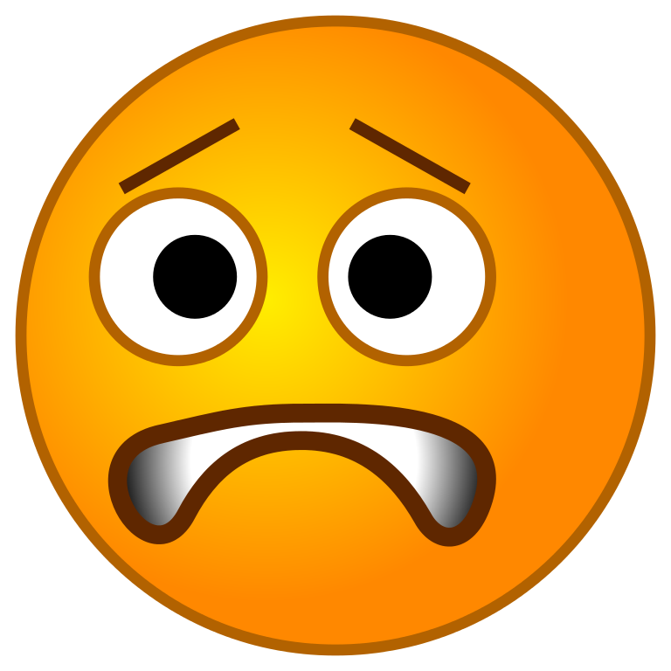 | 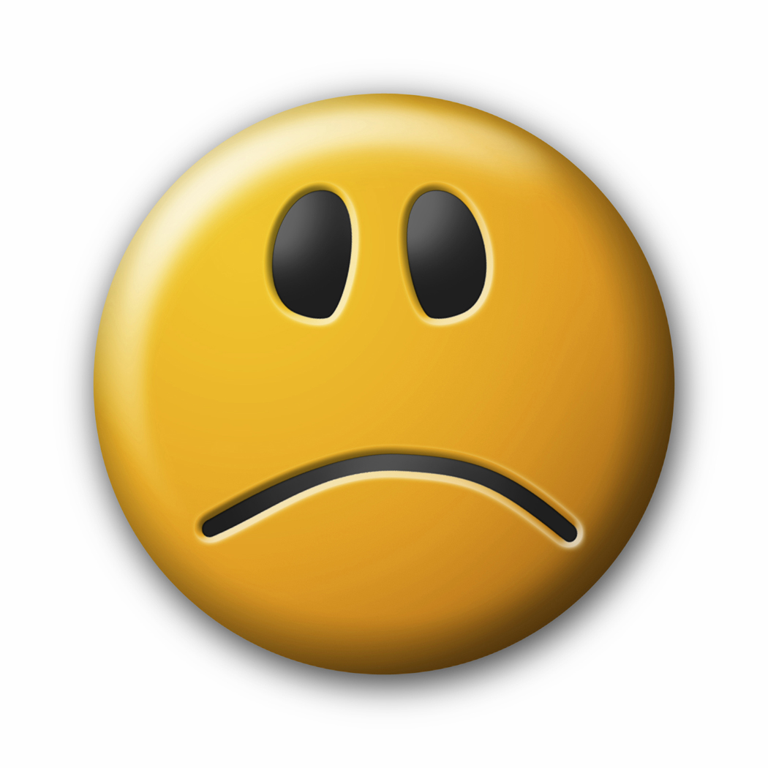 |  | 

Two things that I am looking forward to:
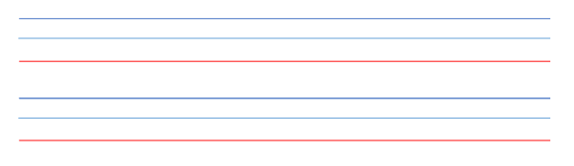

mmmm
Is there anything that Mrs. Wilson and Mrs. Jones needs to know for next week (you or an adult can write or you can draw a picture)?


