  Muslim people always wash their hands before handling the Qur’an | 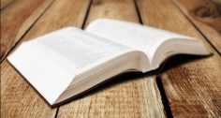  Muslims leave the Qur’an on the floor of the Mosque | Muslims believe that the Qur’an is Allah’s words | 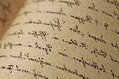  Muhammad wrote down what Allah said to him when he was in the cave
Allah  The Qur’an teaches that there is only one God | 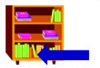  Muslims put the Qur’an on the bottom shelf of a bookcase | Arabic/English  English and Arabic use the same letters | 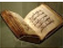  The Qur’an is the 2nd most important book for Muslims
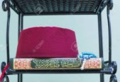  Muslims keep the Qur’an on the highest shelf of the bookcase | 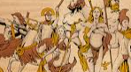  The Qur’an teaches that there are many different gods
Facts About the Qur’an

