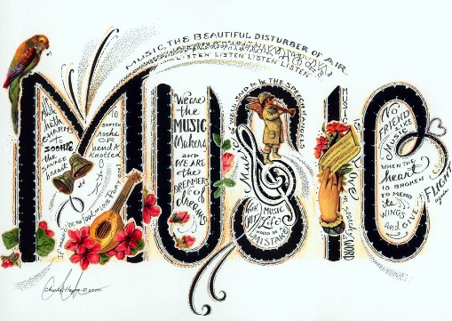
Music
We are continuing our Music Sessions this week. Each week our music session will take no longer than 20 minutes.
https://classroom.thenational.academy/lessons/rhythms-6rtp6c?activity=video&step=1
This week we will be looking at rhythm lesson 2 from the Government’s Oak Academy Key Stage 1. In this lesson, we will identify the rhythm of a song; listen to and repeat simple patterns and create your own simple pattern.

I hope you enjoy it.
This Photo by Unknown Author is licensed under CC BY-SA

