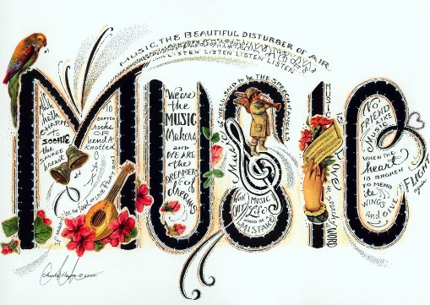
Music
We are continuing our Music Sessions this week. Each week our music session will take no longer than 20 minutes.

This week we will be looking at rhythm lesson 1 from the Government’s Oak Academy Key Stage 1. In this lesson, we will learn the difference between pulse and rhythm and how to learn to and repeat short rhythmic patterns.

https://classroom.thenational.academy/lessons/rhythm-and-pulse-c4tker


I hope you enjoy it.
This Photo by Unknown Author is licensed under CC BY-SA

