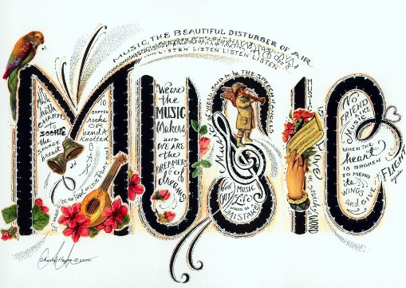
Music
We are beginning our Music Sessions this week. Each week our music session will take no longer than 20 minutes.

This week we will be looking at pulse lesson 2 and creating simple patterns to the pulse of a song. We will be following the Government’s Oak Academy Key Stage 1 lesson from their on-line virtual classroom.
https://classroom.thenational.academy/lessons/creating-simple-patterns-6rwk8d

I hope you enjoy it.
This Photo by Unknown Author is licensed under CC BY-SA

