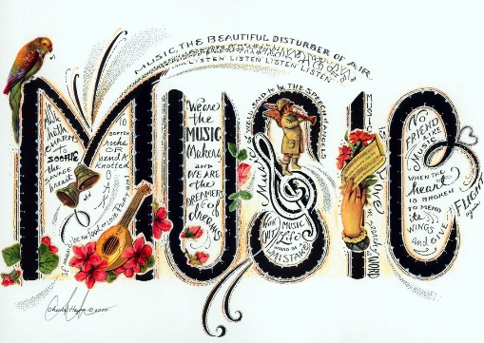
Music
We are beginning our Music Sessions this week. Each week our music session will take no longer than 20 minutes.

This week we will be looking at pulse and moving our bodies to the pulse of a song. We will be following the Government’s Oak Academy Key Stage 1 lesson from their on-line virtual classroom.
https://classroom.thenational.academy/lessons/understanding-pulse-cdk38c

I hope you enjoy it.
This Photo by Unknown Author is licensed under CC BY-SA

