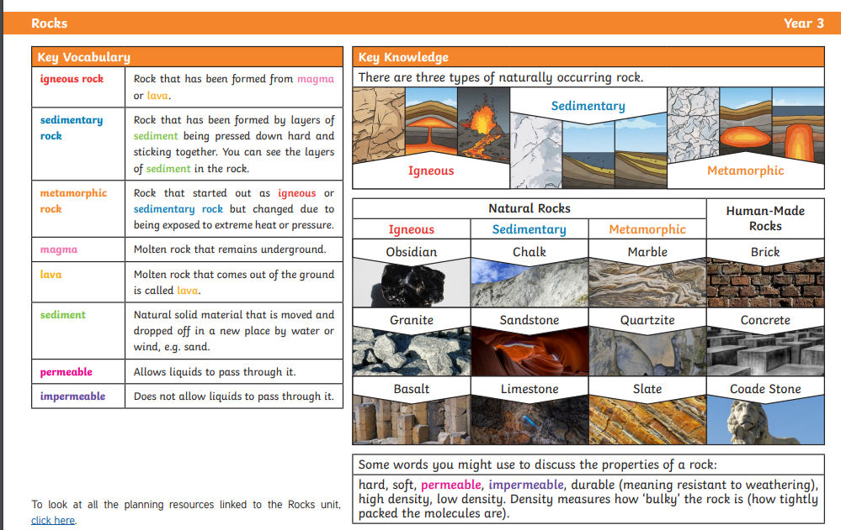
Knowledge Organiser

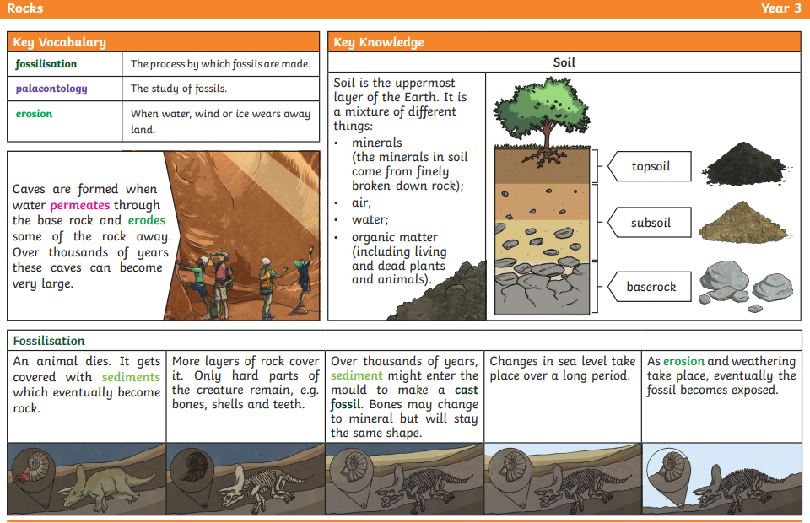

Find a few different rocks in your garden or in an area near your home. Use the information /Knowledge Organiser to help you identify the rocks and their features. Then complete the task below.


