The 5 Oceans of the World Tuesday 2nd March 2021
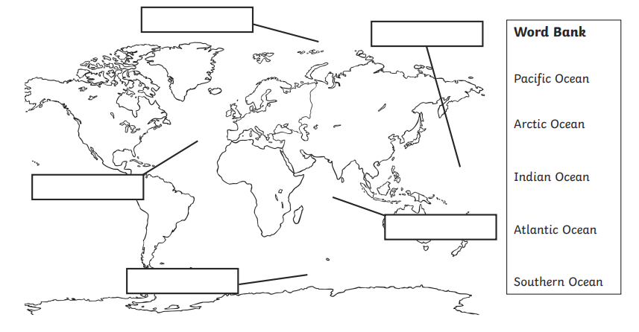
Can you label the 5 oceans? Use the word bank to help you with your spelling. Remember that each continent is a proper noun so needs to start with a capital letter.

After you have labelled the map, I would like you to write down at least one fact about each ocean. Remember to make sure that you write in full sentences and use capital letters and full stops.
The Arctic Ocean has ice that is melting due to climate change.

